This review was made by students at CW West for the purposes of reviewing for the final exam. Please refer to the answer sheets for each section. If you have questions about a problem that you see, please refer to your notes, your text and then your chemistry teacher. If you feel that a question has the wrong answer listed, please let your teacher know.

**Section 1 Chapter 4 – Atomic Structure**

1. Matching: match the scientist to their atomic theory.

John Dalton

A. Performed gold foil experiment and found that electrons are not consolidated in a nucleus like protons and neutrons are.

B. Discovered that subatomic particles have different charges

C. All elements are composed of tiny individual particles called atoms, and atoms of the same element are identical.

D. Atoms are indivisible and indestructible.

Democritus

JJ Thompson

Ernest Rutherford

2. In your own words, define an atom. Illustrate an atom of nitrogen using the Bohr model.

3. How did John Dalton improve upon Democritus’s atomic theory?

4. A sample of sodium has a mass of 22.9898g and contains 6.02x1023 atoms. Find the mass of a single atom of sodium.

5. Describe the location and properties of each type of subatomic particle.

a) Proton

b) Neutron

c) Electron

6. Carbon’s mass number is 12, and this atom has 6 electrons. Assuming it’s a neutral atom, find the number of protons and neutrons.

7. What is an isotope?

8. Find the number of protons and neutrons in an atom of the isotope potassium-25.

9. Find the atomic mass (in amu) of an element if 90% of the element on earth has a mass of 6amu and the other 10% has a mass of 1.157amu.

10. Determine the number of protons and neutrons in the isotope shown.

20

41

**Ca**

**Section 2 *Chapter 5-Electrons**

E=hv, c=λV

1. What was wrong with Rutherford’s model?
2. Explain the Thompson model and Bohr models.
3. What is the energy required to move an electron from one electron shell to another?
4. Does this energy increase or decrease in each electron shell as electrons move further from the nucleus?
5. Write the full electron configuration of Tantalum (Ta).
6. How does the wavelength of a light wave affect its frequency?
7. Explain the wavelength and frequency of a light wave?
8. The wavelength of light ultraviolet is 7m. Find the quanta of this light wave.
9. What is the electromagnetic spectrum? Give order of wave types.
10. What are atomic spectra?

**Section 3 Chapter 6 Review-Periodic Table**

1. What aspect of an atom is used when ordering the elements in the periodic table?
2. What are the three main classifications of elements?
3. What is the orbital notation for Kyrpton?
4. What is the trend from top to bottom and left to right for atomic radius?
5. When do ions form?
6. What are Cations?
7. Where are the transition metals located?
8. Why don’t noble gases share electrons?
9. What group are the halogens in?
10. Define Electronegativity.

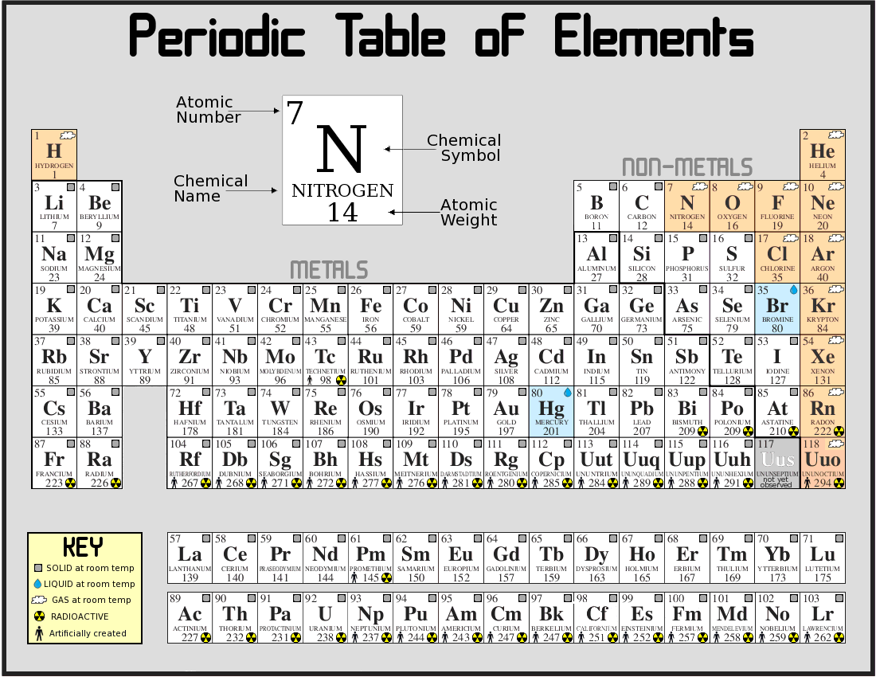

1. Label the three arrows.

**Section 4 Chapter 7 Review-ionic and metallic bonding**

1. How many valence electrons does a neutral atom of nitrogen have?
2. Draw the electron configuration for Sulfur.
3. Draw the electron dot structure for Carbon.
4. What is the chemical formula for the compound formed from K+ and S2- ions?
5. What are three characteristics of ionic compounds?
6. What are alloys?
7. How many electrons would phosphorous have to gain or lose in order to obtain noble gas configuration and what would its charge be?
8. Which following pairs of atoms would be more likely to form an ionic compound when combined chemically?
9. Li and S
10. Na and Mg
11. Draw the orbital configuration for Chlorine.
12. Explain the difference between a cat ion and an anion.

**Section 5 Chapter 8 Review Questions-covalent bonding**

1. Draw a Lewis Dot Structure for CH4
2. What can you discern from a molecular formula?
3. What is the goal stated in the octet rule?
4. What does it mean to be a diatomic molecule?
5. Draw a Lewis Dot Structure for N2 (2 is a subscript)
6. What is a resonance structure?
7. Define the VSEPR theory.
8. Describe a situation where a sigma bond would be formed. Is a pi bond or sigma bond stronger?
9. Give an example of a molecular compound with the tetrahedral shape.
10. How does a polar bond form?

**Section 6 Chapter 9-Chemical names and formulas**

1. What’s the prefix “**tetra-**“ mean?
2. Name the following compound: “**N₂O**”
3. Name the following compound: “**Be(NO₃)₂**”
4. What’s the formula for **Heptachlorine Trifloride**?
5. What’s the formula for **Carbon Tetrachloride**?
6. What kind of elements make a **molecular** compound?
7. What kind of elements make an **ionic** compound?
8. Do **acids** give or receive electrons?
9. Do **bases** give or receive electrons?
10. What is the **Law of Definite Proportions**?

**Section 7 Ch.10 review-Chemical quantities**

1. How many particles are in one mole of any substance?
2. At STP how much volume does one mole of a gas fill?
3. What does the molar mass of a substance represent?
4. What is another name for the quantity 6.02x10^23?
5. How many moles of a substance is 2.80 x 10^24?
6. What is the mass of two moles of silicon?
7. What is the volume of a gas with 2.17 x 10^23 particles at STP?
8. How many moles of hydrogen gas are in 30L?
9. What is the mass of 3 moles of NaCl?
10. At STP what volume do these gases occupy?

A.1.25mol He B.0.335mol C2H6

**Section 8 Ch 11-Chemical Equations**

1. Balance the following equations:
   1. Al + $O_{2}$ ${Al}_{2}O_{3}$
   2. $C_{3}H_{8}$ + $O_{2}$ ${CO}_{2}$ + $H_{2}O$
   3. AL + CuCl AlCl + Cu
2. What types of reactions are seen in the equations above?
3. What is a skeleton equation?
4. What are the five types of chemical reactions?
5. What is a net ionic equation?
6. Write the balance equation for the following reactions
   1. Iron metal and chlorine gas react to form solid iron (III) chloride
   2. Solid aluminum carbonate decomposes to form solid aluminum oxide and carbon dioxide gas
   3. Solid magnesium reacts with aqueous silver nitrate to form solid silver and aqueous magnesium nitrate
7. What substances are always products of a combustion reaction?
8. What is the purpose of a catalyst in a chemical reaction?
9. Balance the following net ionic reactions and their charges:
   1. $Pb{\left(NO_{3}\right)}_{2}$ (aq) + $H_{2}{SO}_{4}$ (aq) ${PbSO}_{4}$ (s) + $HNO_{3}$ (aq)
   2. $Na_{3}PO_{4}$ (aq) + $FeCl_{3}$ (aq) $NaCl$ (aq) + ${FePO}_{4}$ (s)
10. What is a spectator ion?

**Section 9 Chapter 12: Stoichiometry**

$$\frac{Given}{1}×\frac{1 mole of known}{given units}×\frac{coefficient of unknown}{coefficient of known}×\frac{Desired Units}{1 mole of unkown}$$

To solve stoichiometry problems:

* Write a balanced equation
* Convert given to moles
* Establish a ratio of reactants and products
* Convert moles of unknown into the unit that the equation asks for

To find limiting reactant:

* Find amount of moles of each reactant
* Divide moles by its coefficient
* Whatever reactant is smaller is the limiting reactant

To find Percent Yield:

$\frac{Actual Yield}{Theoretical Yield}$

1. If I expect 35 grams of a substance but I get 32 grams, what is my percent yield?
2. Determine the mass of lithium hydroxide produced when 0.38g of lithium nitride reacts with water?
3. How many liters of oxygen are necessary for the combustion of 425 grams of sulfur, assuming that the reaction occurs at STP?
4. What is the limiting reactant if .64 grams of calcium carbide reacts with 200mL of water to form 1.315 grams of calcium hydroxide?
5. In an experiment, if I expect a products mass to be 73 grams but receive 65.2 grams, what is my percent yield?
6. Find the mass of sodium required to produce 5.68 L of hydrogen gas at STP from the reaction described by the following equation:
   * 2Na $+$ 2 $H_{2}$ O -> 2NaOH $+$ $H_{2}$
7. Find the mass of $S_{8}$ required to produce 2.47 L of sulfur dioxide gas at STP from the reaction described by the following equation:
$S_{8}+8O_{2}→8SO_{2}$

8. Using the reaction: 4Al $+ 3O_{2}→2{Al}_{2}O_{3},$
   * Identify the limiting reactant for when 0.225 mol Al reacts with 0.415 mol $O_{2}$
9. Find the mass of aluminum required to produce 4.72 L of hydrogen gas at STP from the reaction described by the following equation:
   * 2Al $+ 3H_{2}SO_{4}→ {Al}_{2}({SO}_{4})_{3} +3H_{2}$
10. What is my percent yield when I expect a mass of 50.8 g but get 46.3 g?

**Section 10**

1. Write a balanced chemical equation for when chlorine and sodium iodide react to produce sodium chloride and iodine.
2. What is a limiting reactant?
3. What is percent yield?

742.01g of yttrium astatide reacts with 1240.77g of praseodymium telluride in a double replacement reaction.

4. Write a balanced equation.

5. What is the limiting reactant?

6. What is the mass of the remaining excess reactant?

7. What is the mass of Yttrium Telluride produced?

8. What is the mass of Praseodymium Astatide produced?

9. Calculate the percent yield if 270.11g of Yttrium Telluride are produced in an experiment.

10. Calculate the percent error.

**Section 11 Chapter 16: Properties of Solutions**

1. Define Solution:
2. How many moles of H2SO4 are necessary to create 0.8M solution in 300ml of water?
3. What is the Formula to measuring Molarity? What does each variable stand for?
4. How many moles are in 1M of NaCl and with 100.0mL?
5. What is the volume of K2CO3 if it has the Molarity of 0.50M and 0.25 moles?
6. Define Molarity:
7. If the Temperature increases what happens to the molecules in the fluid? What happens if the temperature decreases?
8. How many milliliters of aqueous 2.00M MgSO4 solution must be diluted with water to prepare 100.0mL of aqueous 0.400M MgSO4?
9. What is the percent by volume of ethanol (C2H6O, or ethyl alcohol) in the final solution when 85mL of ethanol is diluted to a volume of 250mL with water?
10. How many milliliters of a solution of 4.00M KI are needed to prepare 250.0mL of 0.760M KI?

**Section 12 CHAPTER 17- Thermochemistry**

1. What is thermochemistry?
2. What is heat and how does it transfer from one object to another?
3. What is the equation to find the heat transfer between two substances?
4. Difference between endothermic and exothermic processes?
5. What is enthalpy?
6. What is a thermochemical equation?
7. How many grams of ice at 0C will melt when 43 kJ of heat is added?
8. What is the function of a calorimeter?
9. Is cooking popcorn exothermic or endothermic?
10. A substances with initial temp of -23C with a mass of 37 grams is put into 100 ml of water at 43C with ends with a final temp of 22C. What is the specific heat of the substance?

**Section 13**

Equations:

$$q=m×∆T×c$$

$${∆H}_{Vap}×mol=q$$

$${∆H}_{Fus}×mol=q$$

$$1J=0.239cal , 1 cal=4.184J$$

Thermochemistry Review:

1. What is specific heat?
2. Is this an endothermic or an exothermic reaction?
$CH_{4}+2O_{2}→CO_{2}+2H_{2}O-802.32 KJ$

3. Define these units
   1. Joules
   2. calories
4. Label the heating curve with the correct phases.

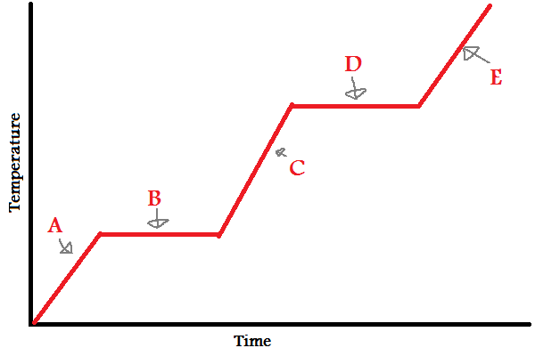

1. What is the difference between the heat of fusion and the heat of vaporization?
2. What is the conservation of energy?
3. Are heat and temperature the same thing? If not, what is the difference?
4. Solve the problem: When 435 J of heat is added to 3.4 g of olive oil at 21 degrees Celsius, the temperature increases to 85 degrees Celsius. What is the specific heat of the olive oil?
5. Solve the problem: Find the total energy released when 14.2 g of water has an increase of temperature from -17 degrees Celsius to 138 degrees Celsius. The heat of fusion is 6.01 KJ/mol, and the heat of vaporization is 40.7 KJ/mol.
6. Solve the problem: In a calorimetry lab, 50 g of lead at 120 degrees Celsius is added into 150 ml of water with the water having an initial temperature of 20.2 degrees Celsius. After the reaction, the temperature of the water was 32.6 degrees Celsius. What is the specific heat of the lead?